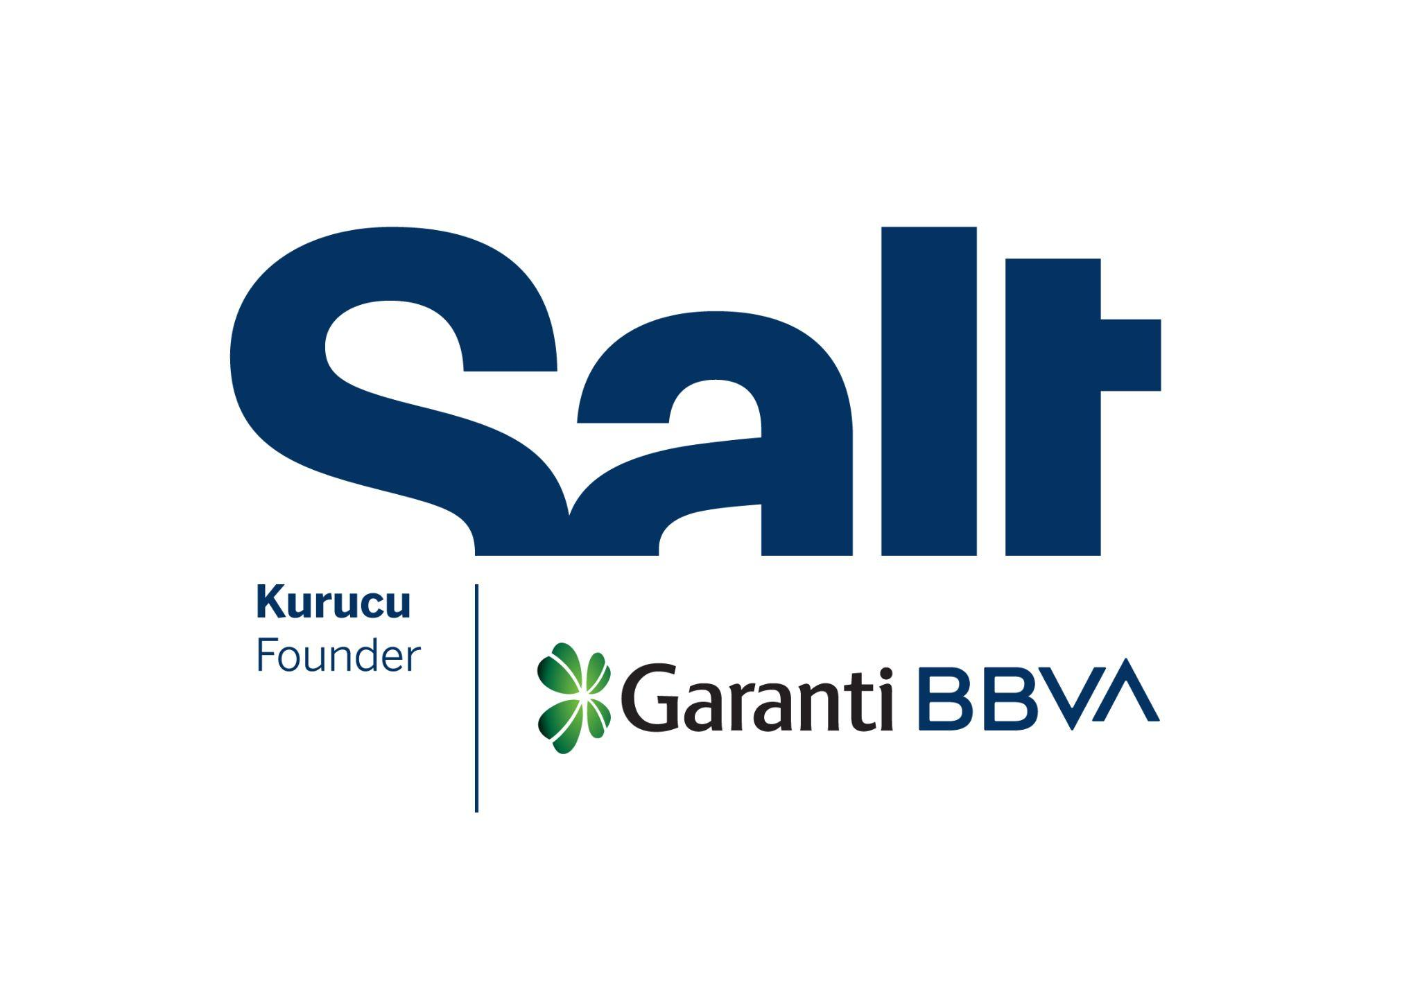

Press Release
May 16, 2025

New Exhibition:
Anatolian Plant Legacy

May 16 – August 10, 2025
Salt Beyoğlu

Exploring the plant diversity of Anatolia through botanical illustration, “Anatolian Plant Legacy” opens in the Kitchen at Salt Beyoğlu.

Founded by Garanti BBVA, Salt’s new exhibition Anatolian Plant Legacy brings together 80 works by 47 botanical artists, focusing on plants that have coexisted and interacted with humankind for thousands of years in Anatolia. The selection includes grains, field crops, fruits, and vegetables, as well as plants used for nourishment, healing, and other purposes.

Rendered with meticulous observation, these species stand as witnesses to a shared legacy, shaping the distinctive flavors, fragrances, textures, and hues of Anatolia. The exhibition highlights the genetic and cultural heritage of local plant species amid the climate crisis and industrial production models that endanger agricultural diversity. It underlines the vital importance of safeguarding this legacy for the future of biodiversity and food security.

Alongside the drawings, the exhibition features a range of resources, including herbarium specimens, historical texts, and manuscripts. Weaving together the contributions of past and present botanical artists and scientists, the exhibition reveals the enduring role of botanical illustration in the production and accumulation of scientific knowledge.

The public programs accompanying the exhibition begin with a presentation and conversation on Sunday, May 18 at 13.30, featuring Martyn Rix, Christabel Frances King, Gülnur Ekşi Bona, Hülya Korkmaz Çalı, and Işık Güner. Martyn Rix will address the role of plants transported from Anatolia to Europe in botanical art practices, while Christabel Frances King, one of the leading figures in scientific botanical illustration, will discuss how this practice contributes to knowledge about Türkiye’s flora. Drawing on their own experiences, Gülnur Ekşi Bona, Hülya Korkmaz, and Işık Güner will reflect on the evolution of botanical illustration in Türkiye.
Anatolian Plant Legacy is part of the Botanical Art Worldwide 2025 program, organized by the American Society of Botanical Artists with participation from 30 countries. The exhibition is realized by the Botanical Art Committee of the Flora Research Association and will be on view in the Kitchen at Salt Beyoğlu until August 10. For more information: saltonline.org.

Anatolian Plant Legacy is realized with the contributions of Eureko Sigorta.

* * *

Artists: Asude Nur Sancaktutan, Ayfer Banaz, Ayla Genç, Aynur Haliloğlu, Ayşe Didem Demir, Ayşe Oran, Berat Mehani, Binali Yıldız, Buket Baydemir, Burcu Baraner Kutluğ, Büşra Bayçelebi Ekşi, Deniz Bozok, Elif Demirci, Elif Şirin, Emel Kangal, Ersin Karabacak, Fatma Şen Gökmen, Ferzan Süngütay, Golshan Zare, Gül Nilhan Tuğ, Gülüm Bağcı, Hande Evrenos, Hürmüz Yeniceli, İdil Saadet Akalın, İnsel Kanca, İrem Sönmez Markopcuoğlu, Kseniia Krokhaleva, Mehmet Kavlak, Melek Sevil Mercan Tiryaki, Nadiye Gezmiş, Naile Akın Sevim, Nalan Sarıkaya, Nilgün Alioğlu, Nilgün Töre, Nurcihan Kahraman, Rachel Rose Mollman, Rahmiye Taşkırdı, Sabite Müftügil, Selda Özel, Sema Niğdeli, Serap Keser, Sevgi Yaltırık Yarman, Sevil Mehdi, Şebnem Akyıldız, Şükran Çiper, Zeynep Sırma Ekşi, Zuhal Yeşim Dursun
Steering Committee: Deniz Bozok, Ersin Karabacak, Sema Niğdeli
Artistic Selection Committee: Gülnur Ekşi Bona, Hülya Korkmaz, Işık Güner
Scientific Selection Committee: Barış Özüdoğru, Burçin Çıngay, Ersin Karabacak, Füsun Ertuğ, Mecit Vural, Tuğrul Körüklü

Salt is founded and supported by Garanti BBVA.

Media Relations
Zeynep Akan
zeynep.akan@saltonline.org
+90 212 334 22 45

