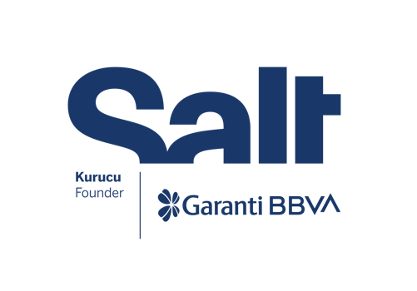

Press Release
April 16, 2025

New Exhibition:
The Lives of Animals

April 16 – August 10, 2025
Salt Beyoğlu

Exploring the evolving relationship between humans and animals throughout history, “The Lives of Animals” is now on view at Salt Beyoğlu.

Founded by Garanti BBVA, Salt’s new exhibition, The Lives of Animals, explores the evolving relationship between humans and animals throughout history—from coexistence to systems of domination. Taking its name from the novel by South African writer J. M. Coetzee, the exhibition draws inspiration from Coetzee’s powerful critique of anthropocentric perspectives, in which he investigates empathy and kindness toward animals. Echoing the novel’s critical stance, it challenges entrenched social hierarchies and practices that shape human-animal relationships while opening space for imagining new forms of coexistence.

At the heart of the exhibition is the work of Lin May Saeed, the German-Iraqi artist and activist who passed away in 2023. Known for her satirical yet poignant depictions of human violence against animals, Saeed’s work is presented alongside contributions by artists from Türkiye and different geographies. The selection also features an archival project centered on the stray dogs of Istanbul.

The exhibition begins with Sonic Space located in the Forum area of Salt Beyoğlu, extending across the second and third floors and concluding in the Winter Garden. Composed of field recordings and sound works by artists working at the intersection of musicology, eco-acoustics, and zoomusicology, this space centers the auditory worlds of animals, offering a site for reflection on interspecies communication through both artistic and scientific lenses. A two-part, site-specific mural by David Maroto interrogates established narratives around domestication, social hierarchy, and the continuity of human-nature relationships—particularly through references to animal iconography from Çatalhöyük.

Moving images, paintings, and installations on the second floor examine themes such as species-based domination, animal liberation, ecological responsibility, and cultural hybridity. Between Care and Violence: The Dogs of Istanbul traces the discourses, spatial politics, administrative and legal processes shaping the lives of dogs in Istanbul since the 1910 Hayırsızada Incident—when over 80,000 street dogs were exiled to Sivriada, the city’s smallest and most remote island. Drawing on a range of archival documents, the work presents a chronology that reveals both the shifting forms of violence enacted against dogs and the culture of care and protection as a countervailing force.

Featuring embroidery, etching, and textile works, the third floor shifts focus to the intertwined themes of care, control, mourning, resistance, and ecological collapse in human-animal relations, as well as individual and collective struggles for nature and animal rights. The Lives of Animals explores the symbolic possibilities of a world in which humans and animals can coexist beyond established hierarchies.

Realized in collaboration with the Museum of Contemporary Art Antwerp (M HKA) as part of L'Internationale’s Museum of the Commons, and programmed by Joanna Zielińska and Fatma Çolakoğlu, the exhibition is on view at Salt Beyoğlu from April 16 to August 10. Public programs accompanying the exhibition will be announced at saltonline.org and Salt’s social media channels.

Artists: Apian, Noor Abuarafeh, Pierre Bismuth, melanie bonajo, Elen Braga, Sue Coe, Golden Snail Opera Collective (Isabelle Carbonell, Joelle Chevrier, Yen-Ling Tsai, Anna Tsing), Elmas Deniz, Simone Forti, Piero Giraldi, Laura Lima, Dafna Maimon, Britta Marakatt-Labba, David Maroto, Ad Minoliti, Füsun Onur, Jean Painlevé, Janis Rafa, Maria Roza, Necla Rüzgar, Lin May Saeed, Uriburu
Sonic Space: Cevdet Erek, Nathan Gray, Kathy High, John C. Lilly, Charlemaigne Palestine and Simone Forti, Dr. Roger Payne, Dr. Joyce Poole and Peter Granli, Lisa Schonberg, Jana Winderen
Research Project: Mine Yıldırım

The Lives of Animals is realized with the support of the Kingdom of the Netherlands, Goethe-Institut Istanbul, Flanders State of the Art, Asya International Movers, and with the contributions of Eureko Sigorta, Jotun, and Bankerhan Hotel.

* * *

Program: Joanna Zielińska, Fatma Çolakoğlu
Coordinators: Alâ Taleb, Zeynep Sarı
Exhibition Design: Işıl Ünal and Cem Kozar (PATTU), Aysu Keten, Başak Aşırok, Fulya Aras
Editor: Can Kantarcı
Translation: Gülin Ekinci, Neylan Bağcıoğlu
Exhibition Production: OCD Museum Works, Çağlar Mobilya, Fuar Led, Zafer Kristal, 3T Reklam, Lamarts, Esprint
Technical Installation: Burak Bodur, Eray Özcan, Mete Bars
Communication Design: Işıl Ünal and Cem Kozar (PATTU), Oya Çitçi, Emir Darman
Salt is founded and supported by Garanti BBVA.

Media Relations
Zeynep Akan
zeynep.akan@saltonline.org
+90 212 334 22 45

