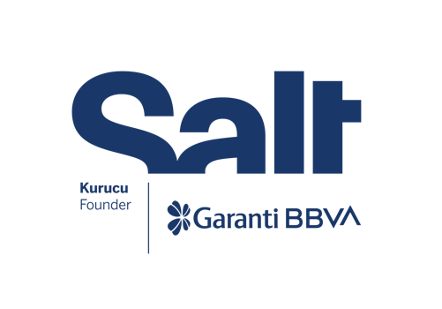

Press Release
March 18, 2025

Salt Artistic Research and
Production Grant Program
2024-2025 Projects

March 19 – June 15, 2025
Salt Galata

The projects supported by the Salt Artistic Research and Production Grant Program, in collaboration with the BBVA Foundation,
are presented at Salt Galata.

The projects selected for the first edition of the Salt Artistic Research and Production Grant Program, in collaboration with the BBVA Foundation, are presented in the Mastercard Exhibition Hall at Salt Galata from March 19 to June 15. The exhibition features works by Aslı Uludağ, recipient of the Artistic Research Grant, and Ali Taptık and Merve Mepa, recipients of the Production Grant.

Hydro-Geothermal Bodies, an outcome of Aslı Uludağ’s ongoing research since 2019, focuses on the development of geothermal energy in Aydın, Manisa, and Denizli. The installation includes a timeline charting the legal, scientific, and economic transformations that have shaped the governance of hydro-geothermal resources in the region, a diagram illustrating the private, public, and communal structures, and a map exposing the spatial implications of events outlined in the timeline and the diagram. Field recordings from interviews with thermal bath owners and users, geological engineers, and village residents are accompanied by a series of videos that explore the local hydro-geothermal relations. Mapping an intertwined network of relations, the installation challenges the mechanisms of scientific measurement while tracing the commons embodied in local practices and built around resources.

In Meshwork, Merve Mepa weaves a multifaceted structure that reflects the entanglement of evolving systems, from ancient weaving practices to the complex infrastructures of modern technologies. The installation centers on the notion of line, derived from linea, meaning “linen thread” in Latin, and explores how linearity manifests across various systems. It reveals how centralized network environments, where connections are concentrated in “power nodes,” shape both physical and digital infrastructures. Whereas “meshwork,” from which the installation takes its title, refers not to a network of connections but to interwoven lines of growth that are in constant flux. Highlighting the fluidity of systems that traverse the earth, the installation unveils the shifting dynamics of connectivity, memory, and power.

Ali Taptık’s ongoing project Osmanbey: Social and Spatial Entanglements investigates the interplay between commerce, urban transformation, and the intricate social fabric of a central Istanbul district. The iteration presented at Salt Galata comprises a two-channel video, along with an installation to be augmented by related documents and photographs throughout the exhibition. Blending visual storytelling with observational research, the work highlights the coexistence of diverse economic activities and the layered histories embedded in the district's urban fabric. It sheds light on how spaces are transformed by overlapping systems of trade, culture, and identity.

The projects were selected by the selection committee—comprising Ala Younis, Elvira Dyangani Ose, Fatma Çolakoğlu, Juan Pujol Rodríguez, Manuel Segade, and Vasıf Kortun—and can be viewed at Salt Galata until June 15.

Aiming to provide a dynamic space for artistic research and production, applications for this year’s edition run until April 7. For more information: saltonline.org.

The exhibition is realized with the contributions of Eureko Sigorta and Jotun.

Founded by Garanti BBVA, Salt is a not-for-profit cultural institution engaging in research, exhibitions, publications, web projects, and public programs at the intersections of visual practices, the built environment, social life, and economic history.

The BBVA Foundation, as the corporate social responsibility of the BBVA Group, is committed to advancing society by promoting and disseminating knowledge through research-based, artistic, cultural, and scientific projects.

Media Relations
Zeynep Akan
zeynep.akan@saltonline.org
+90 212 334 22 45

